Economic Data

Grant Morrison

7/1/2021

library(ggplot2)  
library(tidyverse)

## ── Attaching packages ──────────────────────────────────────────────── tidyverse 1.3.0 ──

## ✓ tibble 3.0.1 ✓ dplyr 1.0.0  
## ✓ tidyr 1.1.0 ✓ stringr 1.4.0  
## ✓ readr 1.3.1 ✓ forcats 0.5.0  
## ✓ purrr 0.3.4

## ── Conflicts ─────────────────────────────────────────────────── tidyverse_conflicts() ──  
## x dplyr::filter() masks stats::filter()  
## x dplyr::lag() masks stats::lag()

## Real Consumption

consumption <- read.csv("consumption_data.csv")

d1 <- 2007.5  
d2 <- 2009.5

ggplot(data = consumption,aes(x=year, y = rpce)) +  
 geom_rect(aes(xmin = d1,xmax=d2,ymin=-Inf,ymax=Inf), alpha = .3, fill ="lightgrey") +  
 geom_bar(fill = "#002776",stat="identity",width = .7) +  
 geom_hline(yintercept = 0,lty = 2, col = "black") +  
 ylab("Percent Change from Preceding Period") +  
 xlab("Year") +  
 theme_bw() +  
 ggtitle("Real Personal Consumption Expeditures 2005 - 2020") +  
 theme(plot.title = element_text(hjust = 0.5))

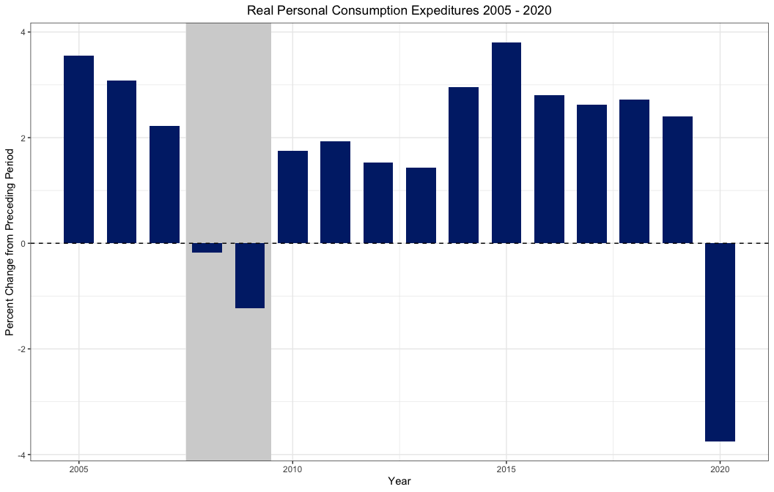

### Real Personal Consumption: Nondurable Goods

ggplot(data = consumption,aes(x=year, y = rpcend)) +  
 geom_rect(aes(xmin = d1,xmax=d2,ymin=-Inf,ymax=Inf), alpha = .3, fill ="lightgrey") +  
 geom_bar(fill = "4a9d36",stat="identity",width = .7) +  
 geom_hline(yintercept = 0,lty = 2, col = "black") +  
 ylab("Percent Change from Preceding Period") +  
 xlab("Year") +  
 theme_bw() +  
 ggtitle("Real Personal Consumption Expeditures: Nondurable Goods 2005 - 2020") +  
 theme(plot.title = element_text(hjust = 0.5))

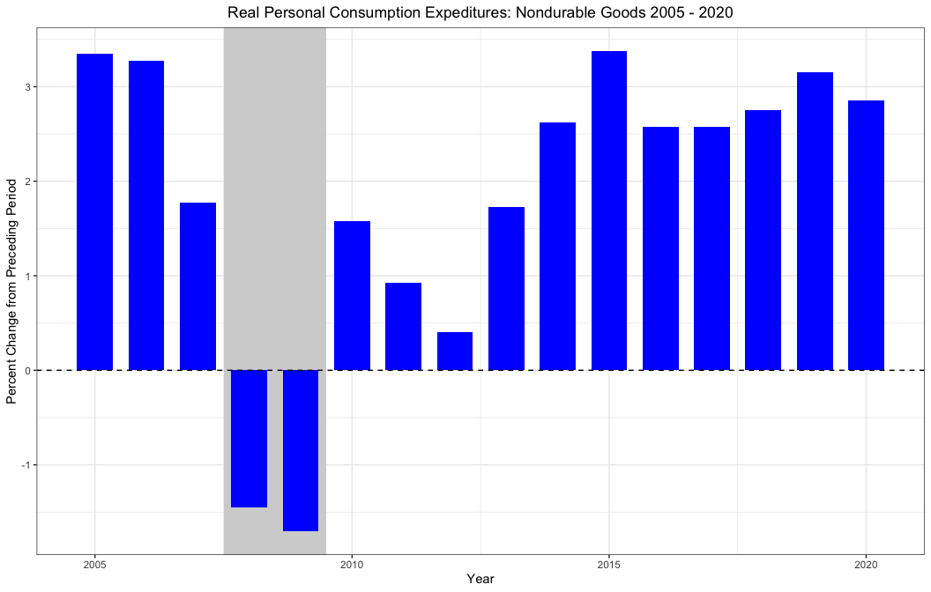

### Real Personal Consumption Durable Goods

ggplot(data = consumption,aes(x=year, y = rpcedg)) +  
 geom_rect(aes(xmin = d1,xmax=d2,ymin=-Inf,ymax=Inf), alpha = .3, fill ="lightgrey") +  
 geom_bar(fill = "#4a9d36",stat="identity",width = .7) +  
 geom_hline(yintercept = 0,lty = 2, col = "black") +  
 ylab("Percent Change from Preceding Period") +  
 xlab("Year") +  
 theme_bw() +  
 ggtitle("Real Personal Consumption Expeditures: Durable Goods 2005 - 2020") +  
 theme(plot.title = element_text(hjust = 0.5))

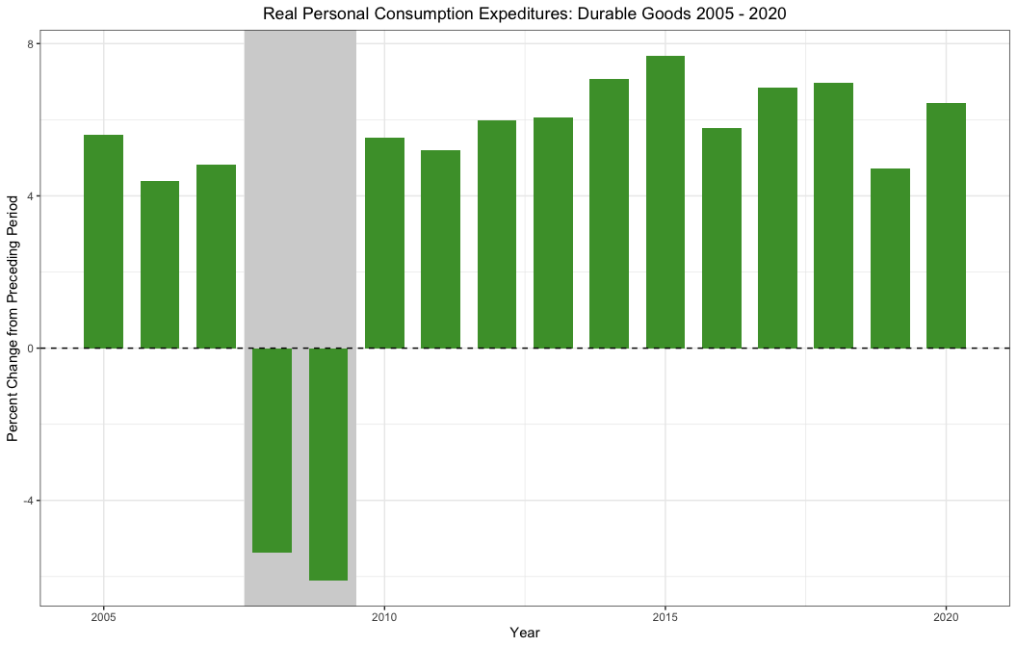

### Real Personal Consumption Services

ggplot(data = consumption,aes(x=year, y = rpces)) +  
 geom_rect(aes(xmin = d1,xmax=d2,ymin=-Inf,ymax=Inf), alpha = .3, fill ="lightgrey") +  
 geom_bar(fill = "#d2492a",stat="identity",width = .7) +  
 geom_hline(yintercept = 0,lty = 2, col = "black") +  
 ylab("Percent Change from Preceding Period") +  
 xlab("Year") +  
 theme_bw() +  
 ggtitle("Real Personal Consumption Expeditures: Services 2005 - 2020") +  
 theme(plot.title = element_text(hjust = 0.5))

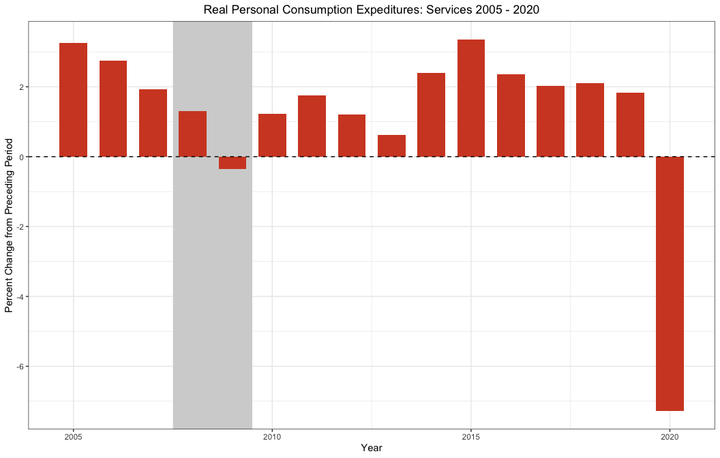

## Real Disposable Personal Income

dpi <- read.csv("real_disposable_income.csv")

Recession dates for the charts

d1 <- as.Date("12/01/07", "%m/%d/%y")  
d2 <- as.Date("06/01/09", "%m/%d/%y")

dpi$DATE <- as.Date(dpi$DATE, "%m/%d/%y")

ggplot(data = dpi, aes(x=DATE,y=DSPIC96)) +  
 geom_rect(aes(xmin = d1,xmax=d2,ymin=-Inf,ymax=Inf), alpha = .3, fill ="lightgrey") +  
 geom_line(col="navy") +  
 theme_bw() +  
 ylab("Billions of Chained 2012 Dollars") +  
 xlab("Date(Monthly)") +  
 ggtitle("Real Disposable Personal Income") +  
 theme(plot.title = element_text(hjust = 0.5))

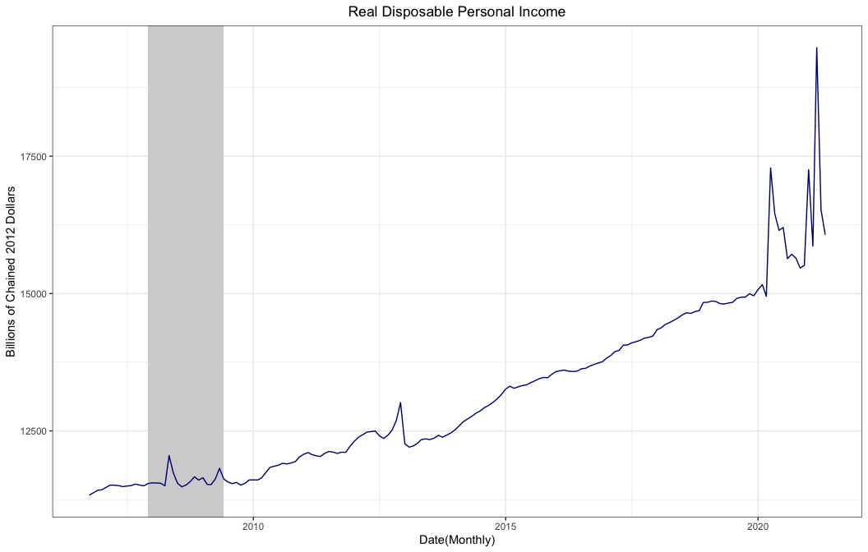

### Unemployment

unemployment <- read.csv("unemployment.csv")

unemployment$DATE <- as.Date(unemployment$DATE, "%Y-%m-%d")

ggplot(data = unemployment, aes(x=DATE,y=UNRATE)) +  
 geom_rect(aes(xmin = d1,xmax=d2,ymin=-Inf,ymax=Inf), alpha = .3, fill ="lightgrey") +  
 geom_line(col="navy") +  
 theme_bw() +  
 ylab("Unemployment Rate(Percent)") +  
 xlab("Date(Monthly)") +  
 ggtitle("Unemployment Rate") +  
 theme(plot.title = element_text(hjust = 0.5))

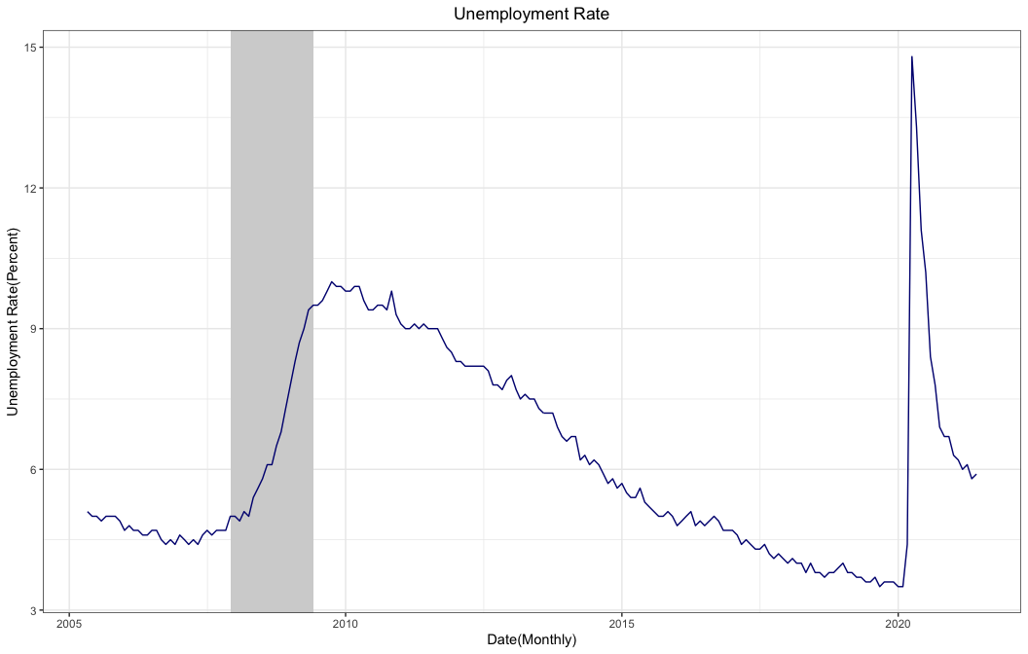

### Real GDP

real_gdp <- read.csv("real_gdp.csv")

real_gdp$DATE <- as.Date(real_gdp$DATE, "%Y-%m-%d")

ggplot(data = real_gdp, aes(x=DATE,y=GDPC1)) +  
 geom_rect(aes(xmin = d1,xmax=d2,ymin=-Inf,ymax=Inf), alpha = .3, fill ="lightgrey") +  
 geom_line(col="navy") +  
 theme_bw() +  
 ylab("Billions of Chained 2012 Dollars") +  
 xlab("Date(Quarterly)") +  
 ggtitle("Real Gross Domestic Product") +  
 theme(plot.title = element_text(hjust = 0.5))

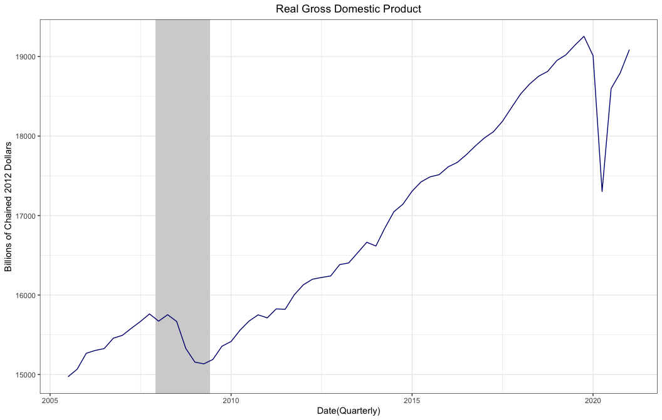

### Debt to GDP

debt_gdp <- read.csv("debt_to_gdp.csv")

debt_gdp$DATE <- as.Date(debt_gdp$DATE, "%Y-%m-%d")

ggplot(data = debt_gdp, aes(x=DATE,y=GFDEGDQ188S)) +  
 geom_rect(aes(xmin = d1,xmax=d2,ymin=-Inf,ymax=Inf), alpha = .3, fill ="lightgrey") +  
 geom_line(col="navy") +  
 theme_bw() +  
 ylab("Percent") +  
 xlab("Date(Quarterly)") +  
 ggtitle("Total Public Debt as a Percent of Gross Domestic Product") +  
 theme(plot.title = element_text(hjust = 0.5))

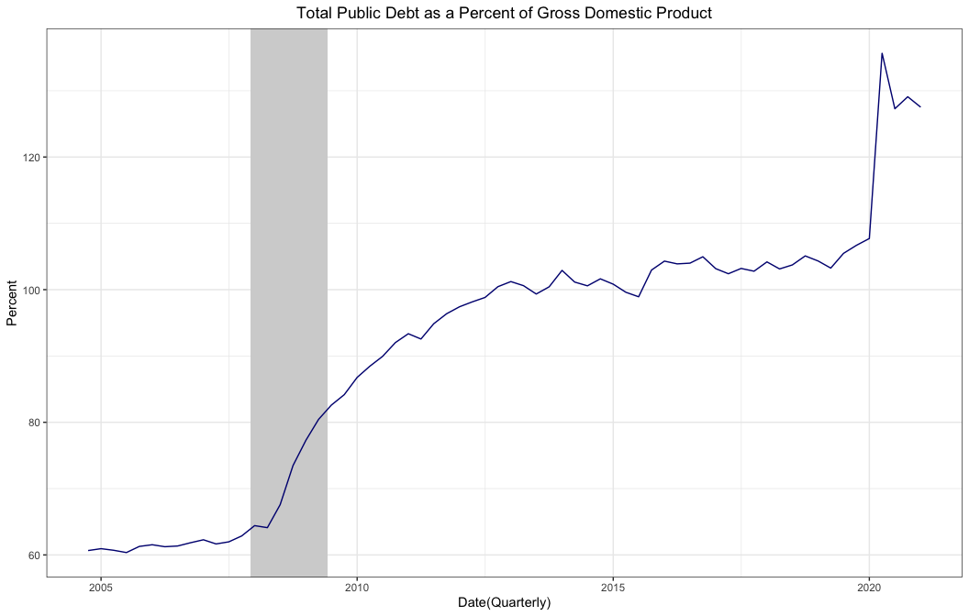

### Personal Savings Rate

personal_savings <- read.csv("personal_savings_rate.csv")

personal_savings$DATE <- as.Date(personal_savings$DATE, "%Y-%m-%d")

ggplot(data = personal_savings, aes(x=DATE,y=PSAVERT)) +  
 geom_rect(aes(xmin = d1,xmax=d2,ymin=-Inf,ymax=Inf), alpha = .3, fill ="lightgrey") +  
 geom_line(col="navy") +  
 theme_bw() +  
 ylab("Percent") +  
 xlab("Date(Monthly)") +  
 ggtitle("Personal Savings Rate as a Percentage of Disposable Income") +  
 theme(plot.title = element_text(hjust = 0.5))

